**Practical No.7**

**Implementation of Identity Management using Cloud Computing concept**

**Aim:** To implement concept of Identity Management in cloud computing

**Concept:** Identity management (ID management) is the organizational process for identifying, authenticating and authorizing individuals or groups of people to have access to applications, systems or networks by associating user rights and restrictions with established identities. The managed identities can also refer to software processes that need access to organizational systems.

Identity management includes authenticating users and determining whether they're allowed access to particular systems. ID management works hand-in-hand with identity access management systems. Identity management is focused on authentication, while access management is aimed at authorization.

ID management determines whether a user has access to systems, but also sets the level of access and permissions a user has on a particular system. For instance, a user may be authorized to access a system but be restricted from

The main goal of identity management is to ensure that only authenticated users are granted access to the specific applications, systems or IT environments for which they are authorized. This includes control over user provisioning and the process of onboarding new users such as employees, partners, clients and other stakeholders. Identity management also includes control over the process of authorizing system or network permissions for existing users and the off boarding of users who are no longer authorized to access organization systems.

**Procedure:**

**Step1:** Open the following link

<https://aws.amazon.com/>

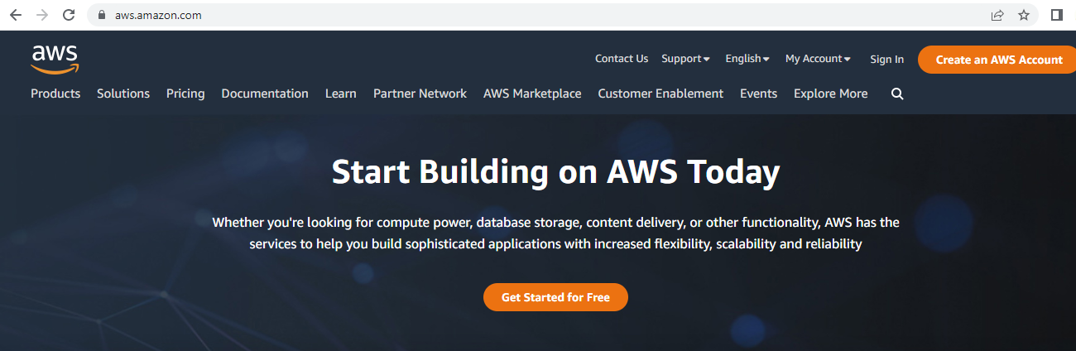

**Step2:** Go to my Account-> AWS management console

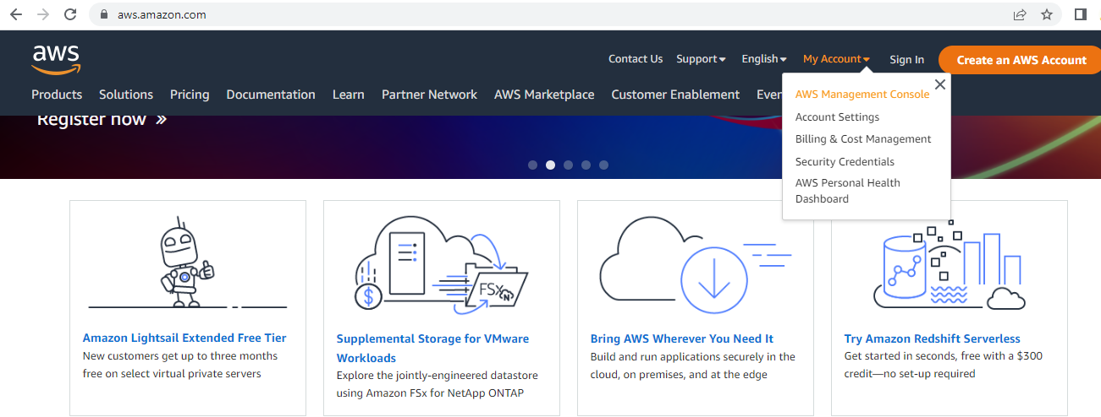

**Step3:** click on Create new user AWS account

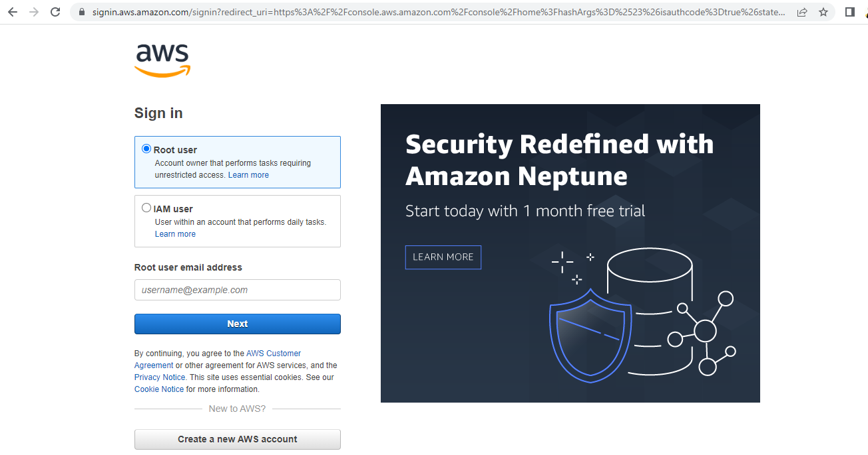

**Step4:** Fill all the details and click on Verify email address

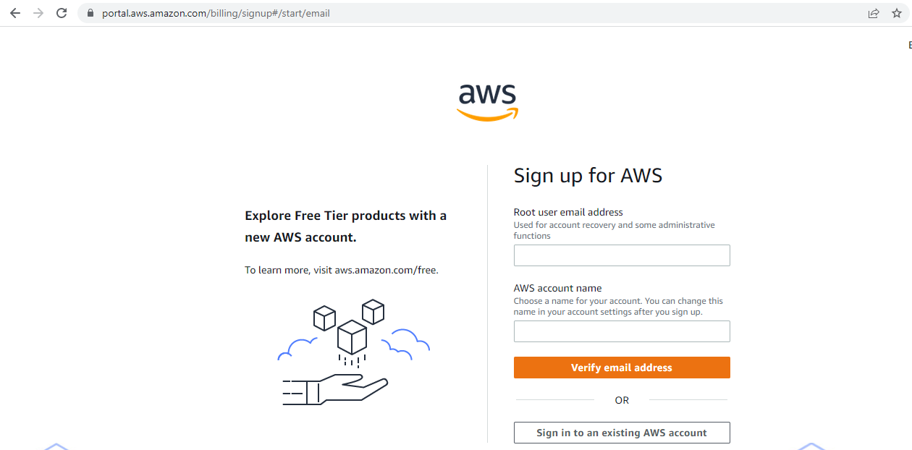

**Step 5:** Add verification code and click on verify.

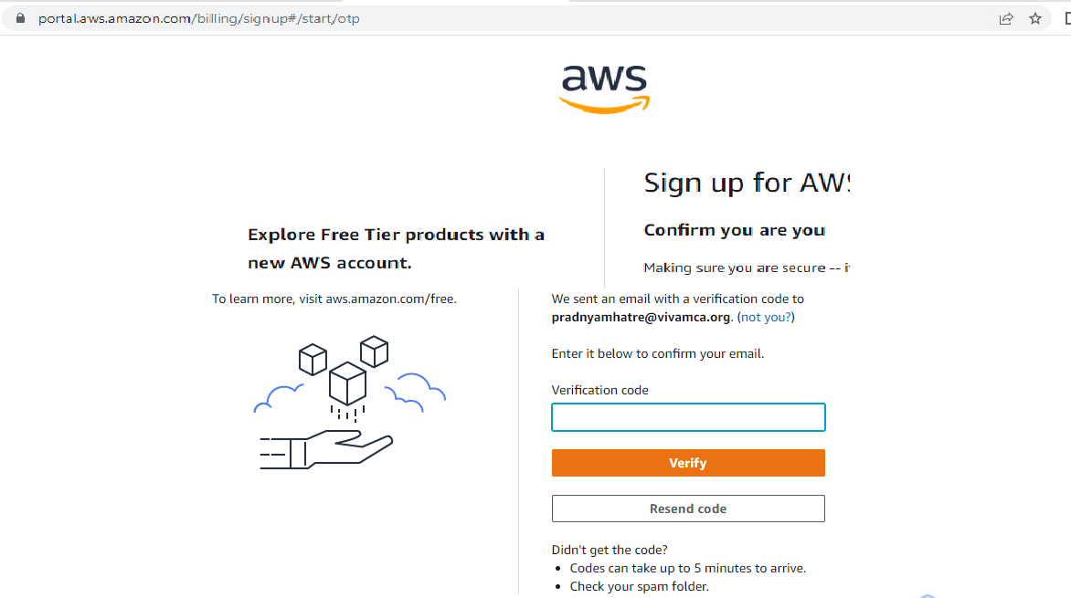

**Step 6:** Create your password and click on continue.

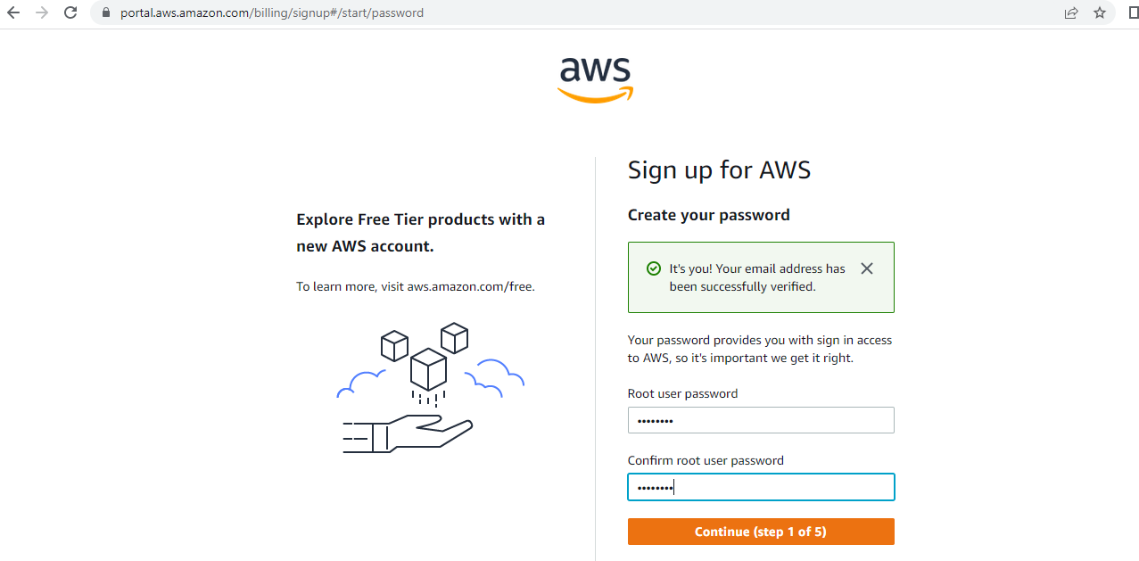

**Step 7:** Fill Contact information and click on continue.

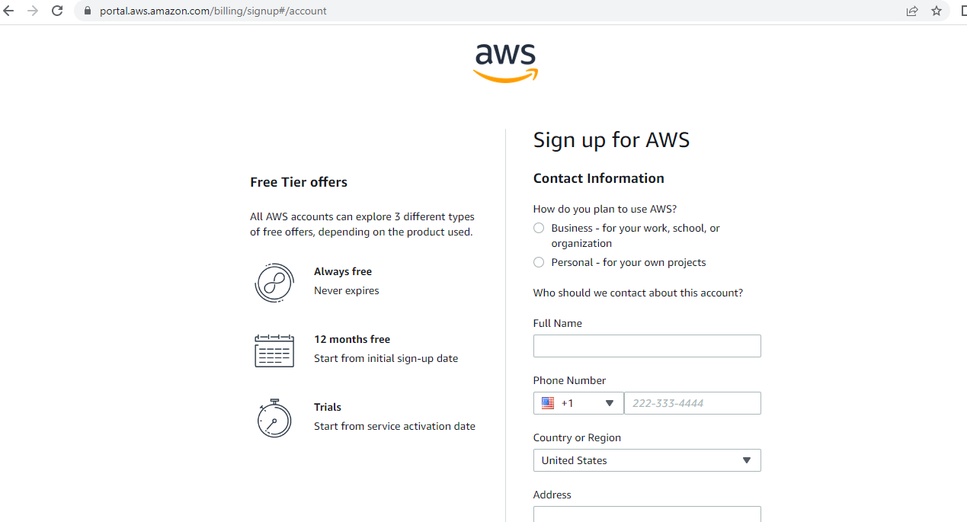

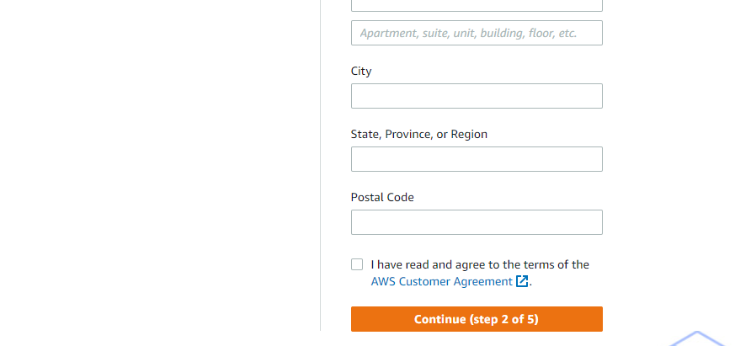

**Step 8:** Now AWS will ask for credit card and debit card details. You

have to close the browser

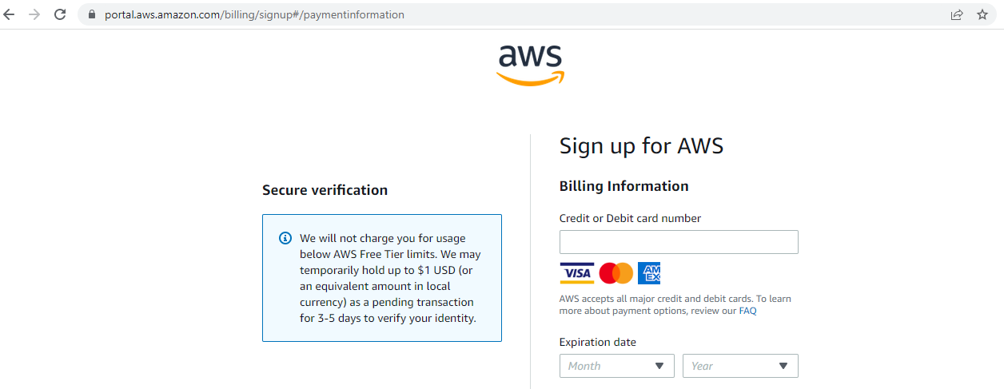

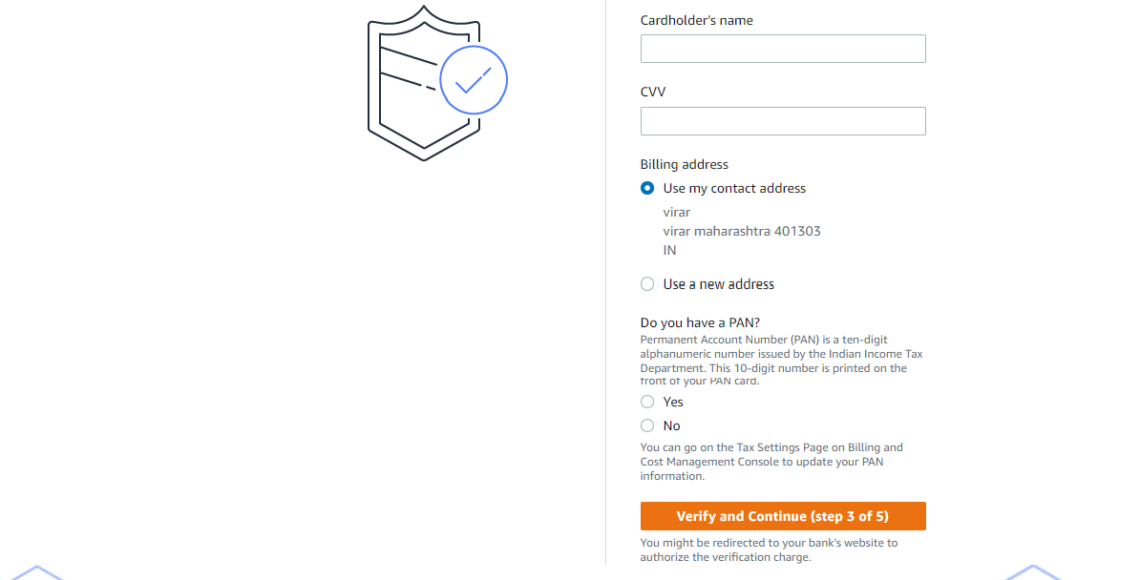

**Step 9:** Go to my Account->AWS Management console

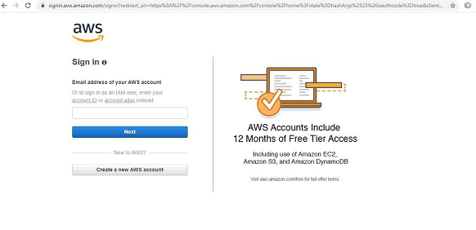

**Step 10:** you will get the following screen

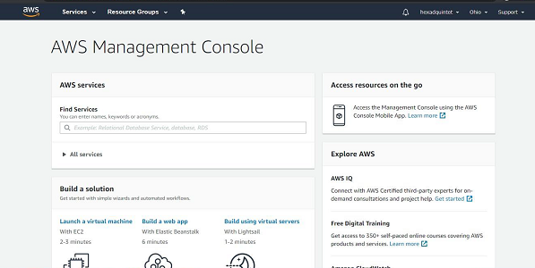

**Step 11:** Go to My Security credential

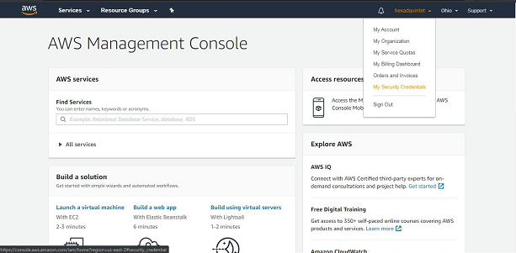

**Step 12:** now click on user

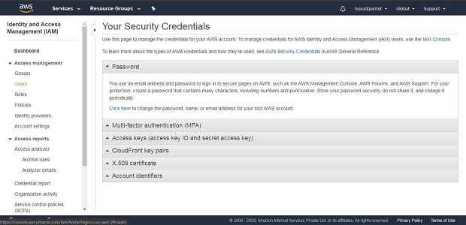

**Step 13:** Click on add user

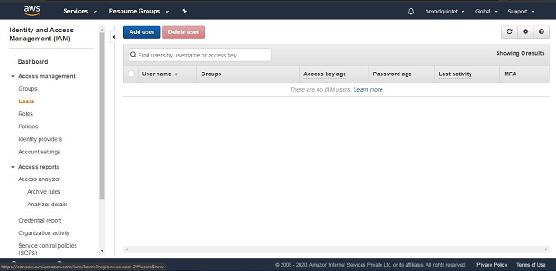

**Step 14:** Provide the user name and check the check box in front of programmatic access

and AWS Management console Access and enter the password for new user

Click on custom password and click on next permission

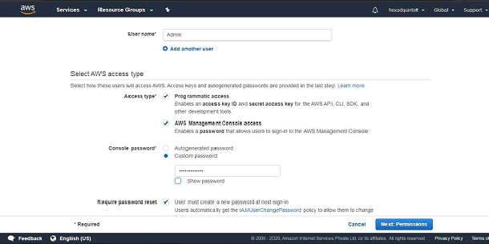

**Step 15:** click on create Group

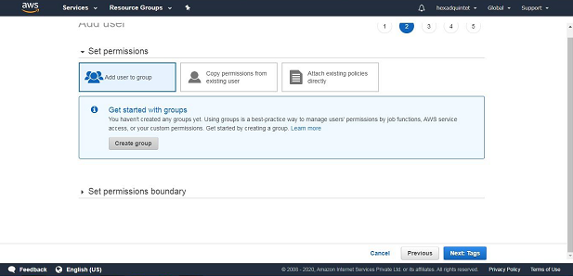

**Step16:** Fill the information and click on Create Group

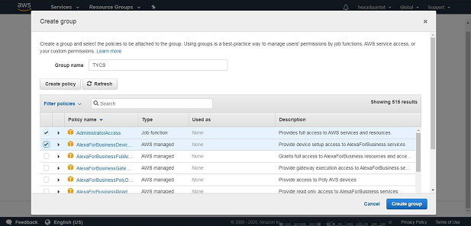

**Step17:** click on next tag leave blank, again click on next review leave as it is and click

on create user

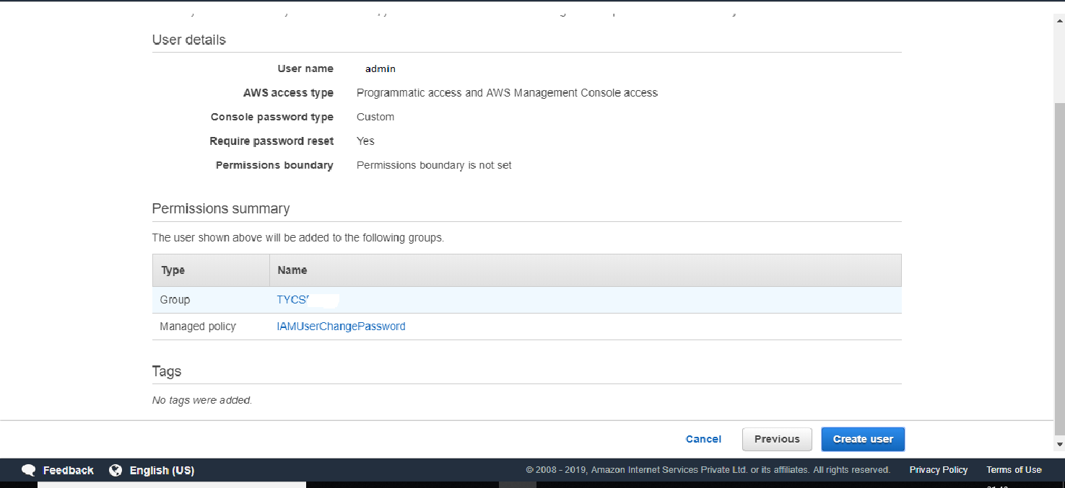

**Step 18:** click on close

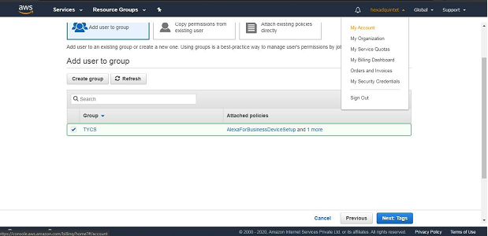

And COPY Account ID

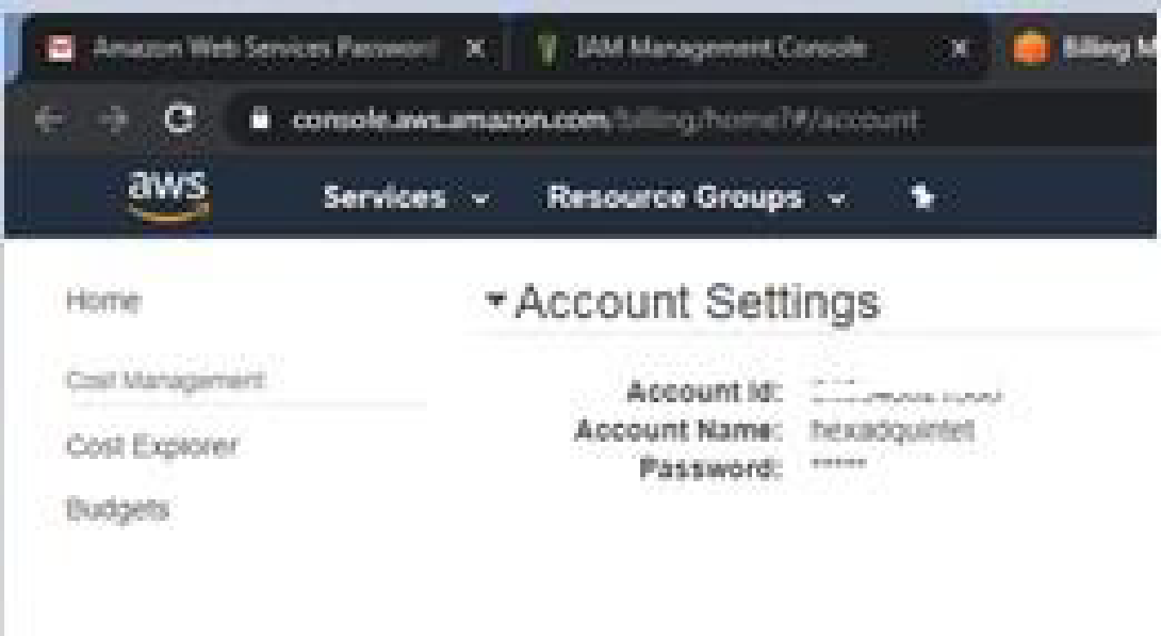

Now logout the admin account and try to login as user (newly created) .

**Step 19:** again Go to my Account->AWS Management console

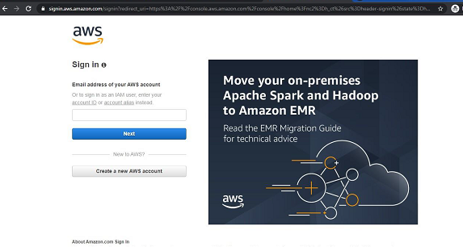

**Step 20:** Click on next Provide the Account ID username and password and click

on sign in It will ask you to change the password which is been set by

administrator

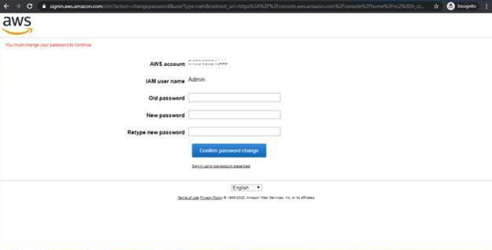

Yow will redirect to home screen

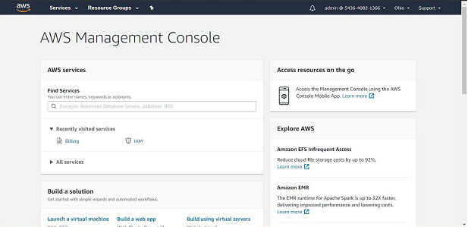

**Conclusion:** Hence we have studied the concept and implementation of identity

management using amazon aws.